CheckUpp Mobile Application – Bugs Report

Document Information
Application: CheckUpp Mobile Application
Report Type: Defect and Usability Findings
Prepared For: Development Team
Version: Current Testing Build
Date: 03 June 2026

Table of Content
CheckUpp Mobile Application – Bugs Report 1
Document Information 1
1. Android Issues 2
1.1 Intermittent Sign-In Failure 2
2. iOS / iPadOS Issues 3
2.1 Date of Birth Selector Text Not Visible 3
2.2 Skip Button Non-Responsive on iPadOS 4
2.3 Incorrect User Interface Scaling on iPadOS 6
3. Cross-Platform Issues (iOS and Android) 7
3.1 Personal Details Validation Triggered Unnecessarily 7

1. Android Issues

1.1 Intermittent Sign-In Failure

Platform
Android

Severity
Medium

Summary
Users may experience intermittent authentication failures during the login process despite entering valid credentials.

Description
During testing on Android devices, the application occasionally fails to authenticate a user after a valid login method is selected. The issue occurs inconsistently and may be resolved by repeatedly attempting to sign in or by restarting the application.
This behaviour has not been observed on iOS devices and appears to be specific to Android.

Expected Behaviour
Users should be successfully authenticated on the first login attempt when valid credentials are provided.

Actual Behaviour
The application intermittently rejects valid login attempts without providing meaningful diagnostic information.

Impact
- Creates uncertainty during onboarding.
- May lead users to believe their account or credentials are invalid.
- Negatively affects user experience and trust.

Recommendation
Implement detailed authentication error handling and provide user-facing error codes or messages to assist with troubleshooting.

Supporting Evidence
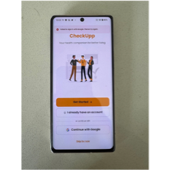

2. iOS / iPadOS Issues

2.1 Date of Birth Selector Text Not Visible

Platform
iOS / iPadOS

Severity
High

Summary
Date picker values are not rendered correctly, preventing users from viewing selected dates during profile setup and other workflows.

Description
The Date of Birth selection component is displayed on screen; however, the day, month, and year values are not visible to the user.
Although the selection wheel remains functional and scrolling interactions can be heard, the text representing the selectable values is not rendered. Users can therefore interact with the control but cannot determine which date is being selected.
This issue has been observed wherever the scrolling wheel date-selection component is used throughout the application.

Expected Behaviour
The date picker should clearly display day, month, and year values while allowing users to scroll and select a date.

Actual Behaviour
- Date picker control is visible.
- Scrolling interaction functions correctly.
- Day, month, and year values are not displayed.
- Users cannot visually confirm their selection.

Impact
- Significantly impacts account setup and profile editing.
- Creates confusion and increases the likelihood of incorrect data entry.
- May prevent successful onboarding for some users.

Supporting Evidence
(https://drive.google.com/file/d/1FriR9iNx6kxWvx80mdOE32NLSsGWlLA6/view?usp=sharing)

Another tab where year was required to be selected
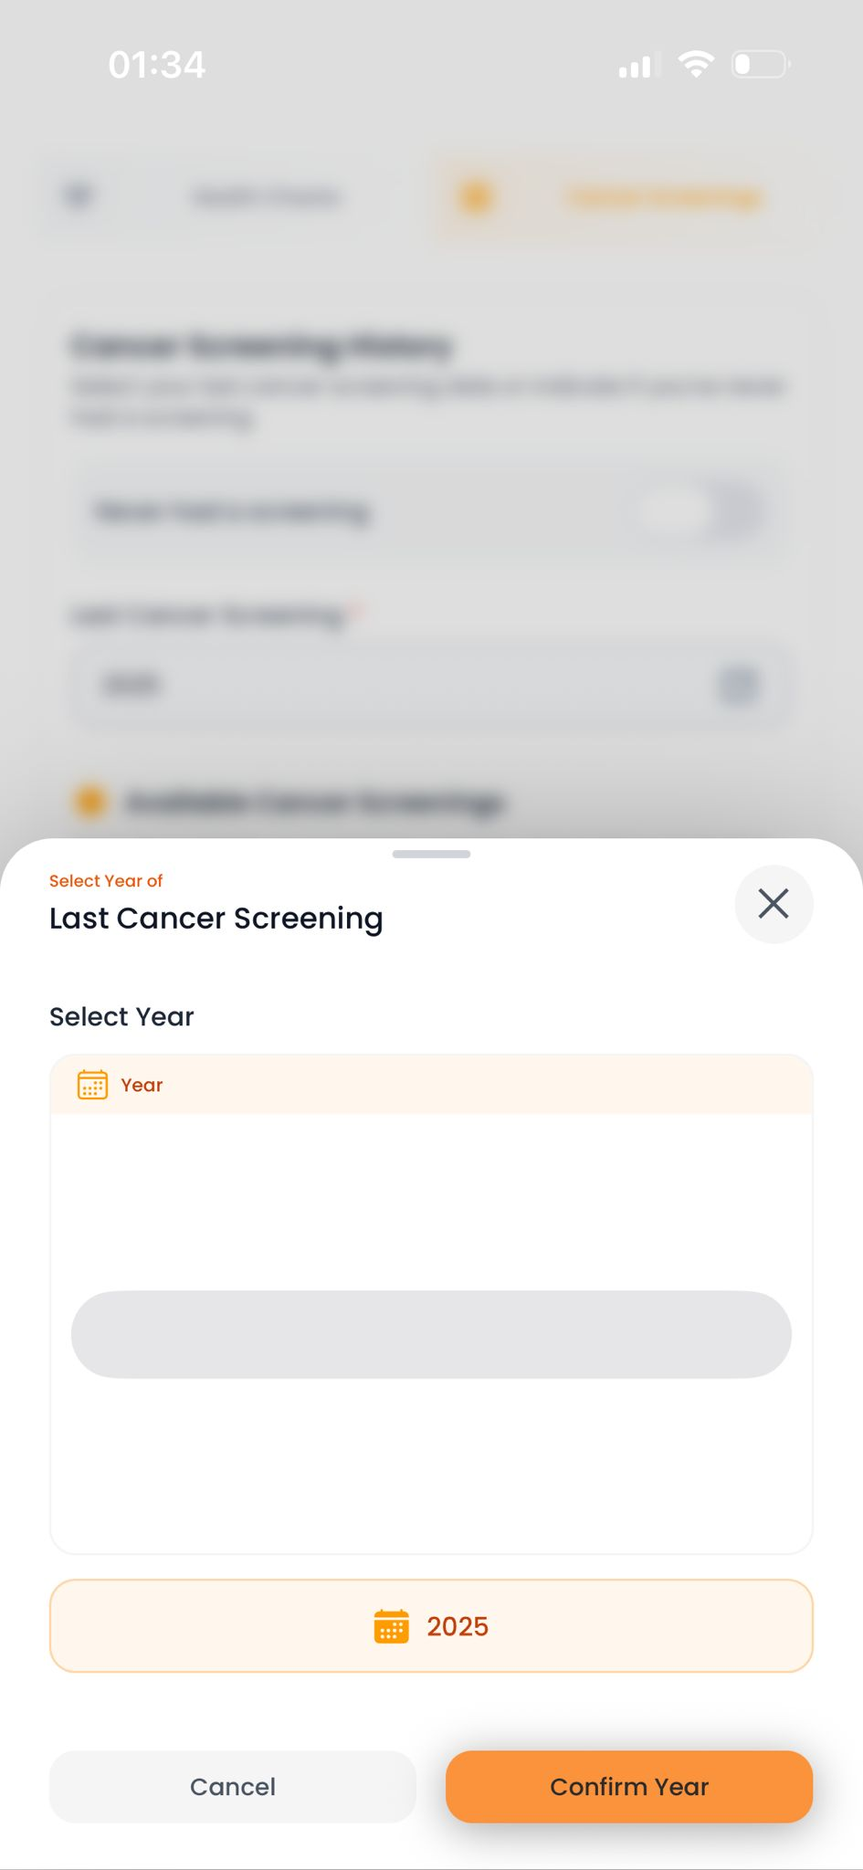

2.2 Skip Button Non-Responsive on iPadOS

Platform
iPadOS

Severity
Medium

Summary
The onboarding "Skip" button is non-functional on the initial setup screen when running on iPadOS.

Description
Testing identified that the Skip button does not respond to user input when the application is launched on iPadOS devices.
The issue is reproducible in both:
- Stage Manager mode
- Windowed application mode
The button only becomes functional after the user proceeds using the "Begin Your Health Journey" action.

Expected Behaviour
The Skip button should be operational immediately upon displaying the onboarding screen.

Actual Behaviour
The Skip button is unresponsive until another onboarding action is completed.

Impact
- Prevents users from bypassing onboarding when intended.
- Creates an inconsistent navigation experience on iPad devices.

Supporting Evidence


2.3 Incorrect User Interface Scaling on iPadOS

Platform
iPadOS

Severity
Medium

Summary
The application interface is not optimised for larger screen sizes and appears to use phone-based layouts on iPad devices.

Description
Several interface elements are positioned incorrectly when viewed on iPadOS devices. The application appears unable to properly distinguish between iPhone and iPad display environments, resulting in layout and scaling inconsistencies.
This behaviour may also affect devices with non-standard screen dimensions.

Expected Behaviour
The application should adapt layouts appropriately based on device type and screen size.

Actual Behaviour
UI elements are misaligned, scaled incorrectly, or positioned inconsistently on iPadOS.

Impact
- Reduced usability on larger devices.
- Poor visual presentation.
- Potential accessibility concerns.

Supporting Evidence
(https://drive.google.com/file/d/1B_cRZzOBdxSc56B4wDmmaIvF1ghLX4lt/view?usp=sharing)

3. Cross-Platform Issues (iOS and Android)

3.1 Personal Details Validation Triggered Unnecessarily

Platform
iOS and Android

Severity
Medium

Summary
Users are prompted to complete profile information that has already been provided during account creation.

Description
After successfully completing account registration, users can revisit the Personal Details page to review or update their information.
When attempting to leave the page without making changes, the application incorrectly prompts users to complete required profile fields, despite those fields already containing valid information from the initial registration process.

Expected Behaviour
Users should be able to exit the Personal Details screen without prompts if no changes have been made and all required information is already present.

Actual Behaviour
The application triggers validation prompts and requests profile completion unnecessarily.

Impact
- Creates confusion regarding profile status.
- Introduces unnecessary user actions.
- May lead users to believe their profile information was not saved correctly.

Supporting Evidence
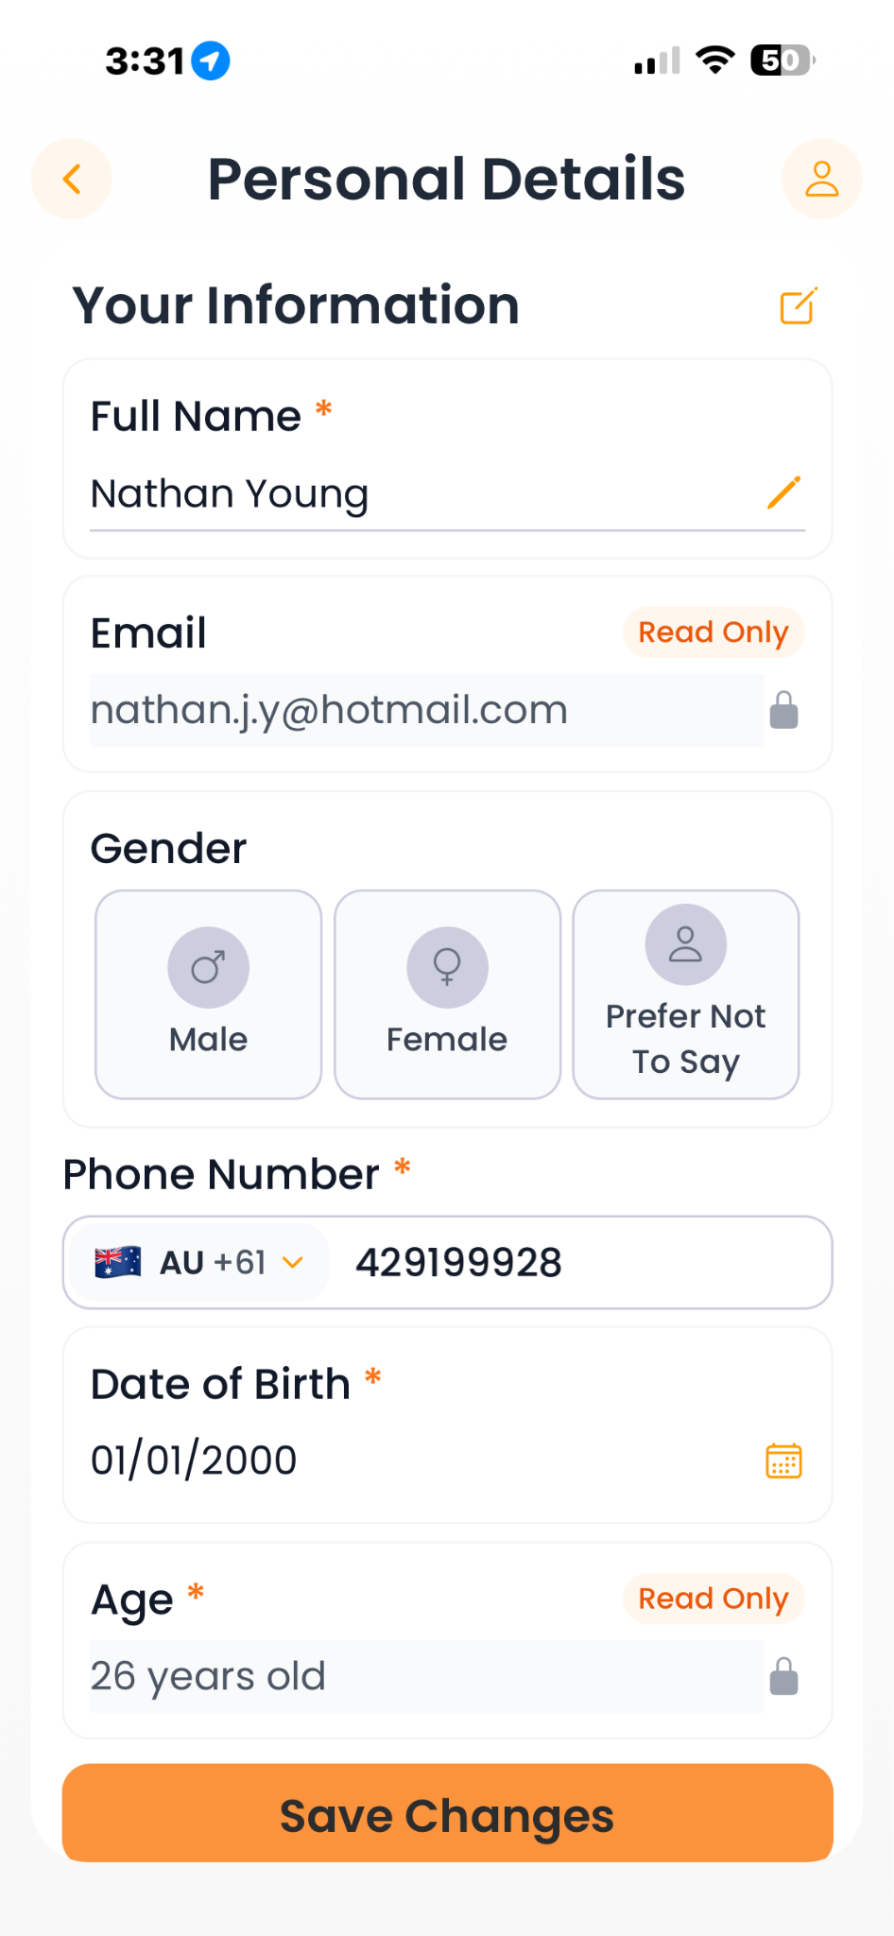

3.2 Application Opens on Personal Details Screen After Inactivity

Platform
iOS and Android

Severity
Medium

Summary
After the application has been inactive for an extended period, reopening the app redirects users to the Personal Details page instead of the Home screen.

Description
When the application is reopened after several hours of inactivity, users are unexpectedly navigated to the Personal Details screen rather than the application's Home screen.
In many cases, the application specifically prompts the user to select or re-enter their gender information, even though this information has previously been provided and saved within the user's profile.

Expected Behaviour
Returning users should be directed to the Home screen (or their last valid session screen) when reopening the application, provided they are already authenticated.

Actual Behaviour
The application redirects users to the Personal Details page and requests profile information that has already been completed.

Impact
- Creates confusion regarding whether profile information has been saved.
- Interrupts the normal user workflow.
- May indicate issues with session restoration, profile state persistence, or onboarding completion status.

Recommendation
Review session management, onboarding completion flags, and profile validation logic to ensure previously completed profile information is retained and recognised correctly after extended inactivity.

Supporting Evidence



